Create table account (

Accid int primary key,

Custid int,

Type varchar(20) not null,

Balance double (15,2) check (balance > 0),

Constraint fk_custid foreign key (custid) references customer(custid) on delete cascade on update cascade

);

Create table customer (

Custid int primary key,

Cname varchar(30) not null,

Address text not null,

Mgrid int,

Constraint fk_mgrid foreign key (mgrid) references manager(mgrid) on delete set null on update cascade

);

Create table manager (

Mgrid int primary key,

Mname varchar (20) not null,

Mobile char(15) unique

);

insert into manager values(100,”tanaya”,0100020);

insert into manager values(101,”ram”,0102020);

insert into manager values(103,”raj”,0103030);

insert into customer values(200,”raju”,”pune”,100);

insert into customer values(202,”rama”,”mumbai”,101);

insert into customer values(203,”karan”,”nashik”,101);

insert into customer values(204,”kirti”,”nashik”,100);

insert into account values(1000,200,”saving”,2000);

insert into account values(1001,200,”dmat”,2050);

insert into account values(1002,203,”dmat”,3023);

insert into account values(1004,202,”demat”,3000);

insert into account values(1003,202,”current”,4000);

1. Display cusid, name, acid, balance, manager id for all customers.

Select c.custid, c.cname,a. accid,a.balance,c.mgrid

From account a , customer c

Where c.custid = a.custid;

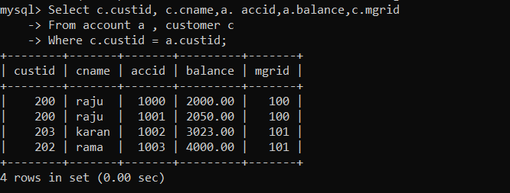

2. Display cusid, name, acid, balance, manager id for all customers who stays in nashik.

Select c.custid, c.cname,a.accid, a.balance,c.mgrid

From customer c ,account a

Where c.custid=a.custid and c.address =”nashik”;

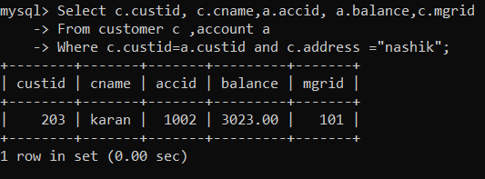

3. Display cusid, name, acid, balance, manager id for all customers whose relation manager is

Tanaya.

Select c.custid,c.cname,a.accid,a.balance,c.mgrid

From account a inner join customer c on a.custid=c.custid

Where c.mgrid=(select mgrid from manager where mname = “tanaya”);

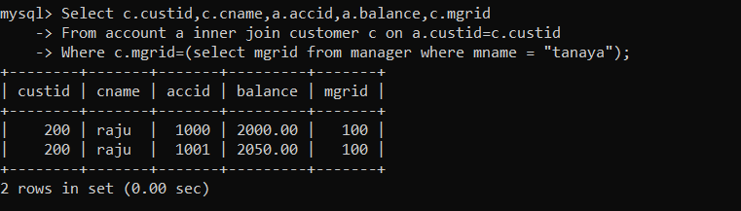

4. Display cusid, name, acid, balance for all customers whose relation manager name starts

with r.

Select c.custid,c.cname,a.accid,a.balance

From account a inner join customer c on a.custid=c.custid

Where c.mgrid in (select m.mgrid from manager m where m.mname = “r%”);

5. Display all customer details and account details who has demat account.

Select c.custid,c.cname,a.accid,a.type,a.balance,c.address,c.mgrid

From customer c inner join account a on c.custid=a.custid

Where a.type=”demat”;

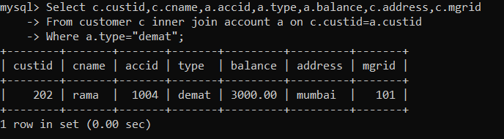

6. Display all manager details and customer details of all customers who has saving account.

Select c.custid,c.cname,c.address,m.mgrid,m.mname,m.mobile

From customer c inner join manager m

On c.mgrid=m.mgrid

Where c.custid = (select custid from account where type =”saving”);

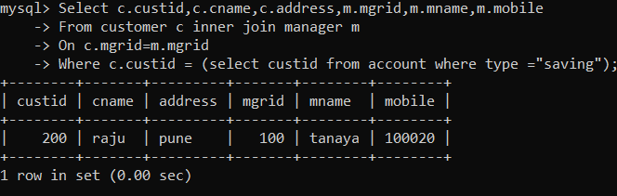

7. Display all account details and customer details whose balance > 3000 and customer stays in

Pune.

Select c.custid,c.cname,a.accid,a.type,a.balance,c.address,c.mgrid

From customer c inner join account a on c.custid=a.custid

Where a.balance > 3000 and c.address =”pune”;

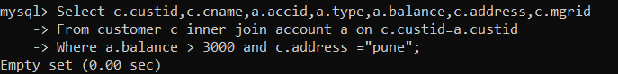

8. Display all customer details , manager details also display all managers who is not relation

manager of any customer.

Select c.custid,c.cname,c.address,m.mgrid,m.mname,m.mobile

From customer c right join manager m

On c.mgrid=m.mgrid;

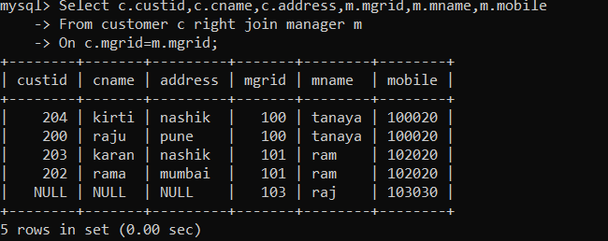

9. Display all customer details , account details also display all customers who has not opened

any account.

Select c.custid,c.cname,a.accid,a.type,a.balance,c.address,c.mgrid

From customer c left join account a on c.custid=a.custid;

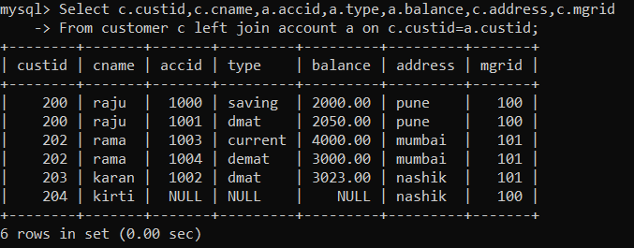

10. Display all customer details , account details and manager details, also display all customers

who has not opened any account, and also display all managers who is not relation manager

for any customer.

Select c.custid,c.cname,c.address,m.mgrid,m.mname,m.mobile, a.accid,a.type,a.balance

From customer c left join account a on c.custid=a.custid left join manager m on m.mgrid =c.mgrid

Union

Select c.custid,c.cname,c.address,m.mgrid,m.mname,m.mobile,null,null,null

From customer c right join manager m on m.mgrid = c.mgrid

Where c.custid is null;

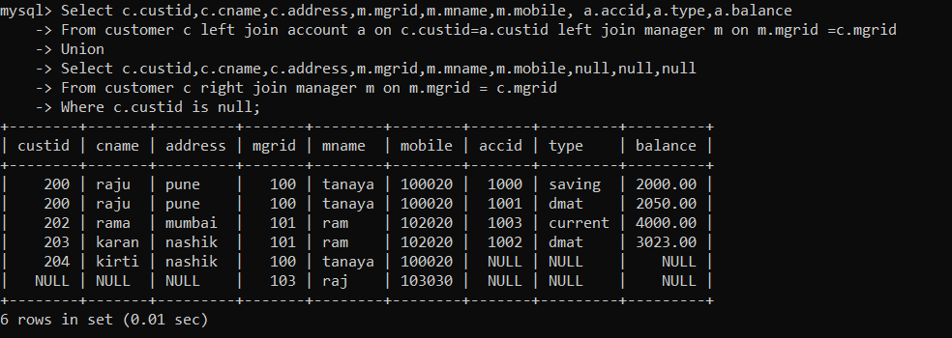

11. To find all managers who is not relation manager for any customer.

Select *

From manager

Where not exists (select * from customer where customer.mgrid = manager.mgrid);

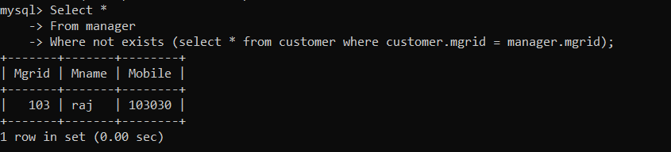

12. Display all manager details whose customer stays in nashik

Select *

From manager

Where mgrid in (select mgrid from customer where address = “nashik”);

